Meta Title: Development & digital marketing services | Get in touch today!
Meta Description: If you need exceptional development and digital marketing services, we are the right professionals for you. We can help your business thrive digitally.

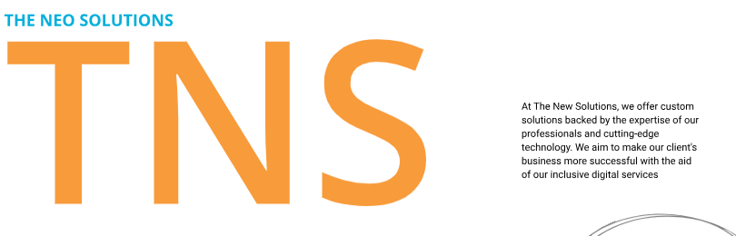

Development & Digital Marketing Services!
We offer innovative custom development and 360° digital marketing services. We can help you grow your business with targeted marketing strategies and data-driven development solutions.
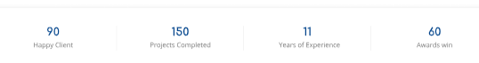
90+ | 150+ | 11+ | 60+
Happy Clients | Projects Completed | Years of Experience | Awards Won
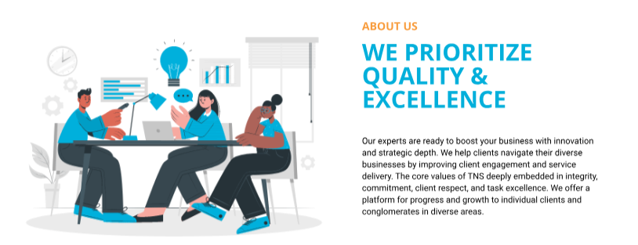

Outperform Competition

We get more business for your Business!
We provide you with custom development solutions and digital marketing services that make a real difference. With us by your side, you can grow your business into a leading brand in your industry area.
- Stronger Online Visibility | - Increased Business Leads | - Better Social Media Performance
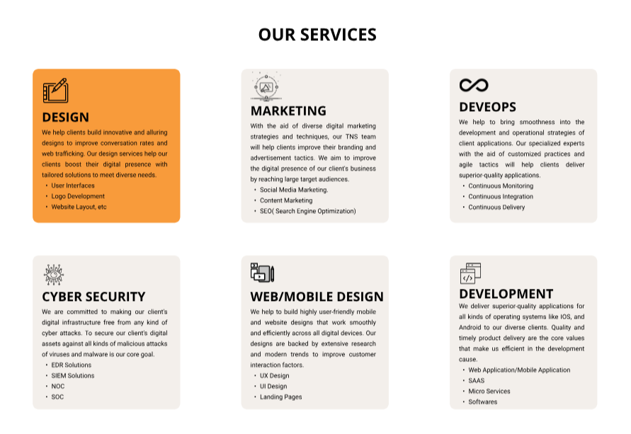

Our Digital Marketing services & solutions span the entire digital ecosystem!
Search Engine Optimization | Custom Website Development | Mobile App Development | Social Media Marketing
Graphic Design | Email Marketing | Software Development | DevOps
Search Engine Marketing | Content Marketing | Ui/Ux design | Cybersecurity
 | SaaS Development | Video Design

Projects big or small, we do it all!
Whether you are looking for a digital marketing agency for small business startups, a medium-scale business, or a large enterprise, we work with all. You can rely on The Neo Solutions to create custom development and marketing solutions that are industry-specific and meet your needs and budget. We can:
- Maximize user engagement
- Drive eCommerce growth
- Increase brand awareness
- Optimize your platforms
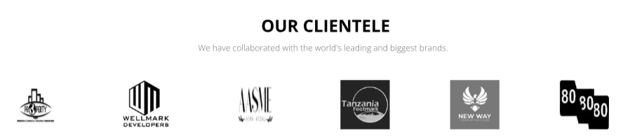

Our clientele
Even the industry-leading brands and businesses need The Neo Solutions from time to time!

Why Choose The Neo Solutions?
We can help you dominate the digital landscape! We are strategic thinkers with high marketing and development expertise who can help unlock your business potential. Unlike any other development and B2B digital marketing agency, we back our services and solutions with strong core values. We take care of all your digital and tech needs.
- Creative Design Services
- Perfect Development solutions
- 360° Digital Marketing services

Industries we serve:
We can propose the right strategy for your business based on the industry trends and tactics.
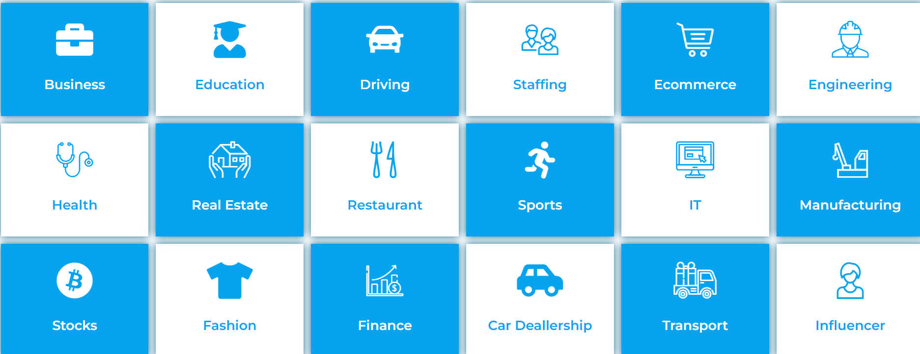
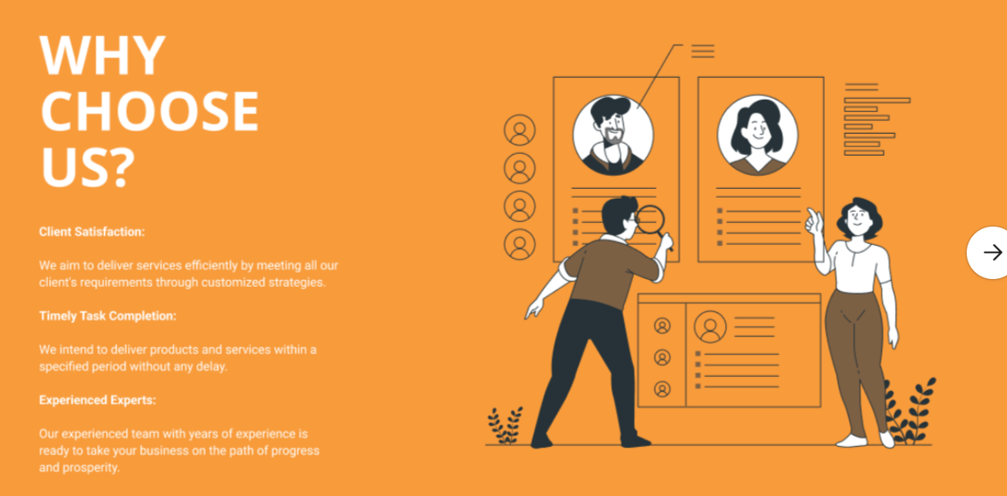

Experience Redefined Marketing and Development!
At The Neo Solutions, we offer practical marketing and development solutions for your business. Unlike any other full-services digital marketing agency, we go a step ahead and offer clear communication, full transparency, and high creativity. You can count on us to create 360° growth for your business.

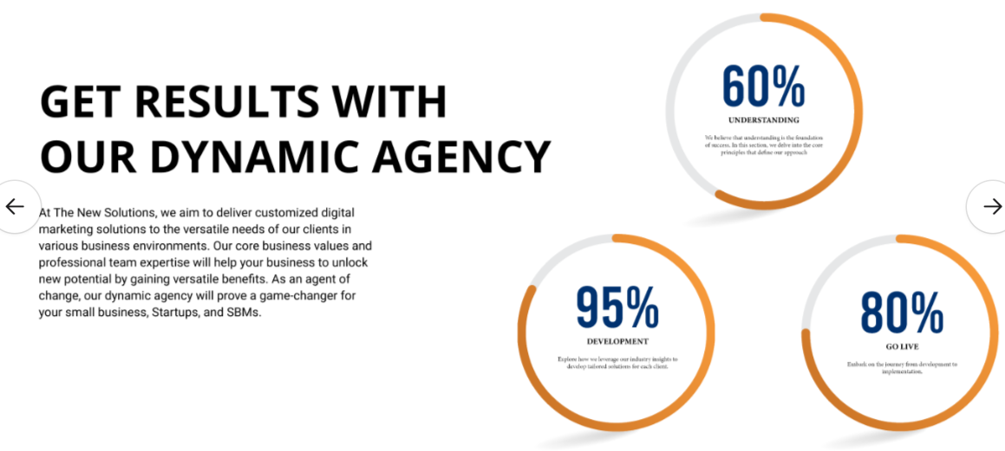

Ready to achieve your marketing & development goals? | Timely Solutions  Experienced Experts
While every other development or eCommerce digital marketing agency executes strategies blindly, our approach is fully data-driven and work-proven to maximize your business success. What’s more, our development and digital marketing services align with your business needs. Our digital marketers and developers are always happy and ready to help you. | Low Pricing

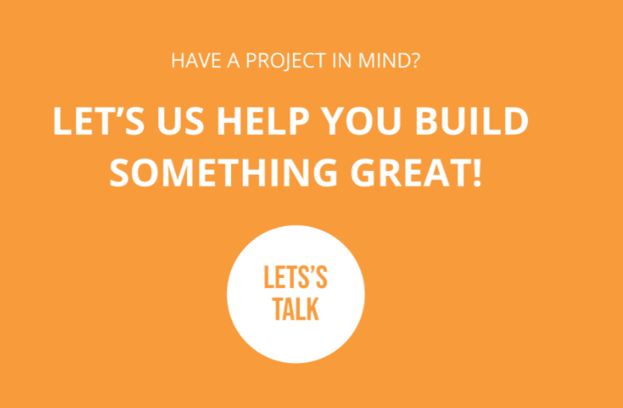

Have a project in mind?

Let’s discuss the development and marketing strategy!
Get in Touch!

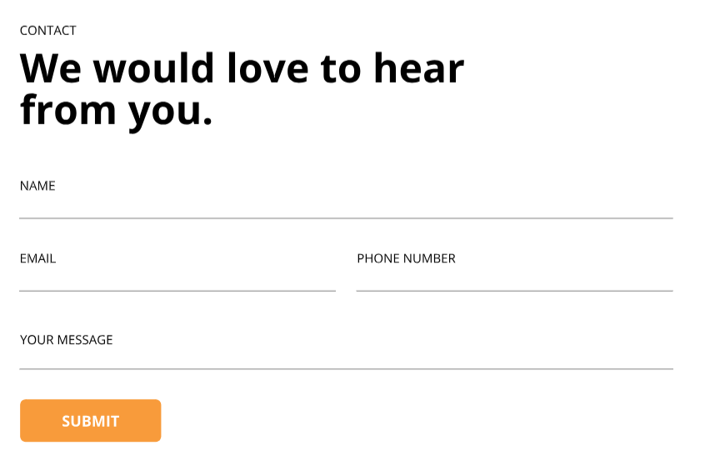

Contact Us!

Want to discuss business or careers?

